Lab: Gosu Classes

In this lab, you will create a Gosu class, write a new method, and connect the method to a new button.

Overview

TrainingApp needs additional capabilities so that users can standardize contact addresses. For example, certain abbreviations (such as "St.") should be replaced with the fully spelled equivalent (such as "Street"). Although it would be better to implement this requirement using entity enhancements, for the purposes of this exercise you should use static methods.

Tasks

1. Create a new package called "training_ext". Its parent should be the "gw" package.
2. In the training_ext package, create a class named AddressCleanupUtil.
3. Create a static method in AddressCleanupUtil that receives an ABContact and checks the address line 1 field for all address associated with the contact. If the field ends in "St.", then the "St." is replaced with "Street".

**Hint 1:** You can use the endsWith method in the gw.api.util.StringUtil class to determine if a string ends with a given set of characters.

**Hint 2:** You can retrieve the beginning of a string using the substring method in the gw.api.util.StringUtil class. It takes three parameters: the initial string, the position of the first character to include (where 0 denotes the first position), and the position *after* the last character to include. For example, if string x is set to "To be or not to be", then gw.api.util.StringUtil.substring(x, 3, 5) returns "be".

**Hint 3:** You can retrieve the length of a string using the string's length property. For example, if string x is set to "To be or not to be", then x.length is equal to 18.

1. Create a button on the Addresses screen toolbar that meets the following criteria:

* The button label is "Scrub Addresses".
* The button is available only when the user is in edit mode.
* When clicked, the button executes the static class method created above.

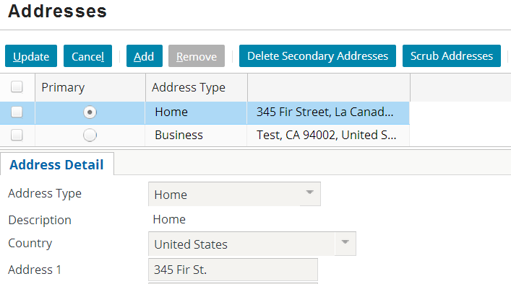

Verification

1. To test the PCF method:

* Modify a contact's primary address so that it end is "St.".
* Verify that the button is not available in read-only mode.
* Verify that, when clicked, the button replaces "St." with "Street" on the primary address.

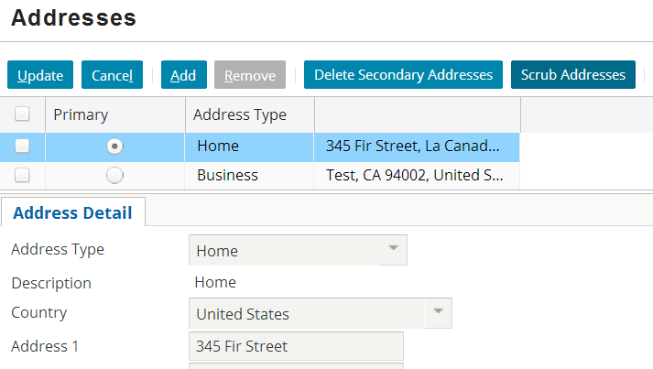

|  |  |
| --- | --- |
|  | Stop and ask your instructor to review your completed lab. |